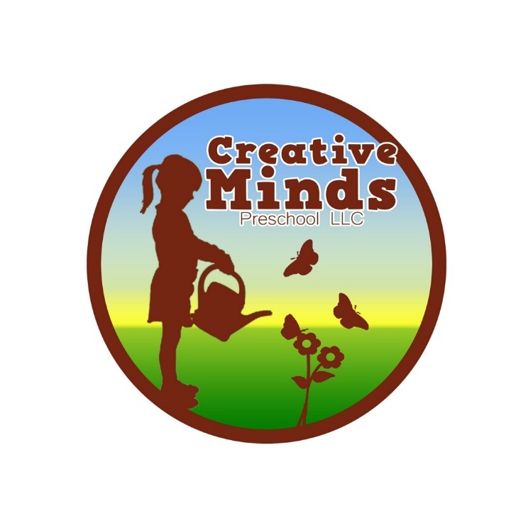

A creative approach to educating young minds
Consent for Pictures/Creative Minds Facebook Page/Website

I, the undersigned parent or guardian of the child, _______________________ authorize my child to be photographed while attending Creative Minds . Pictures may/may not (Please circle one) be shared on our private group Facebook page.

Date:________________________________________________
Signature:__________________________________________________________________

